|  |  |
| --- | --- |
| **Document Title:** | **Lx1 EM Battery Rework** |

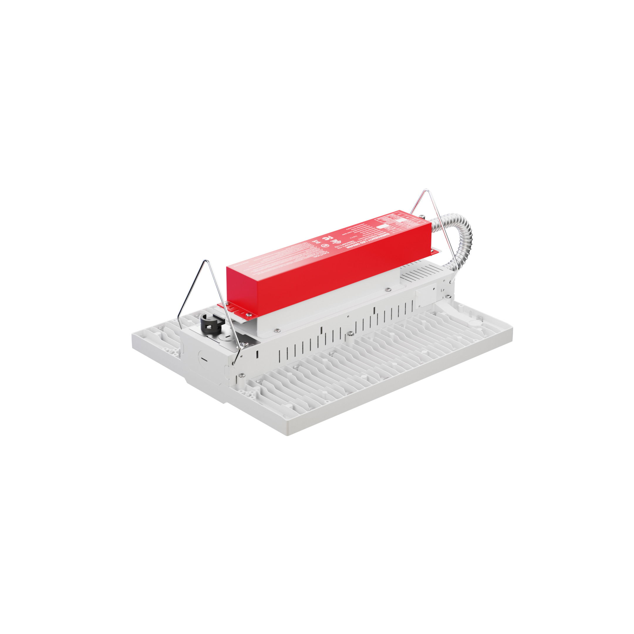

Table of contents

1.0 PRODUCT SPECIFICATIONS 3

2.0 PURPOSE 3

3.0 SCOPE 3

4.0 REQUIRED EQUIPMENT & MATERIALS 3

4.1 AC powered equipment 3

4.2 Additional tools & equipment 3

4.3 Consumable Items with Part Numbers 4

4.4 Consumable Items 4

5.0 BOM 5

6.0 PROCEDURES 6

6.1 Install the EM Battery and Test Button 6

6.2 Quality Control Steps 15

7.0 REFERENCED & SUPPORTING RESOURCES 16

8.0 GLOSSARY 16

9.0 ROLES & RESPONSIBILITIES 16

10.0 CAUTIONS, EHS, AND SAFETY PRACTICES 17

10.1 Danger: electrical shock and burn hazard 17

10.2 Required safety precautions: 17

11.0 Revision History 18

12.0 Current Revision Approvals 18

# PRODUCT SPECIFICATIONS

|  |  |
| --- | --- |
| **Product/Part Information** | |
| **Product Name** | Lx1 with EM Battery |
| **Part Number(s)** | Lx1 (LA1, LS1) |
| **Part Revision** | V1 |

# PURPOSE

1. To provide instructions for the rework of the Lx1 (LA1 and LS1) base model to include the emergency battery (EM battery) accessory option.
2. To serve as training material when onboarding technicians.

# SCOPE

1. These instructions are applicable only to the Lx1 product line.
2. This document captures instructions for the attachment of the EM battery to the Lx1 fixture, instructions for quality control and testing, as well as the boxing and labeling of the final product.

# REQUIRED EQUIPMENT & MATERIALS

## AC powered equipment

|  |  |  |
| --- | --- | --- |
| **Name Used in Document** | **Description & Specification** | **Manufacturer & Model** |
| Power strip | 120v, standard US three prong plug | Any |

## Additional tools & equipment

|  |  |  |
| --- | --- | --- |
| **Name Used in Document** | **Description & Specification** | **Manufacturer & Model** |
| Channel lock pliers | Must accommodate 0.5”-1”, electrically insulated | Any |
| Electric screwdriver | Low-torque, cordless electric screwdriver | Bosch 12v, PS21 3601J92912 *(or equivalent)* |
| Power test cable | A custom 120v cable with two-way Wago connectors attached to live, neutral, and ground. Used for power testing purposes. | Constructed in-house |
| Scissors | N/A | Any |
| Screwdriver (PH1 bit) | Philips screwdriver, PH1 bit or head, electrically insulated | Any |
| Screwdriver (PH2 bit) | Philips screwdriver, PH2 bit or head, electrically insulated | Any |
| Torque screwdriver | Digital Torque Screwdriver 2.66-53.1in-lbs / 0.3-6Nm, ¼” sq. drive, acc. to +/-2%(cw) | VANPO, model # VP027 *(or equivalent)* |
| Wire cutters | Diagonal or needle nose, electrically insulated | Any |

## Consumable Items with Part Numbers

|  |  |
| --- | --- |
| **Name** | **Part Number and Product Code** |
| Product labels (blank) | Part Number: LBL-Lx1-PS-400-300  Code: A0061  [[Sharepoint hyperlink to label images]](https://frankshum-my.sharepoint.com/:f:/g/personal/frank_filamento_lighting/Ev0sJN8iJORMrfG7PLHse-oBEVIAOBQiDyUBOto2yHpUfw?e=eqEsuG) |
| Box labels (blank) | Part Number: LBB-Lx1-PW-400-400  Code: A0060  [[Sharepoint hyperlink to label images]](https://frankshum-my.sharepoint.com/:f:/g/personal/frank_filamento_lighting/Ev0sJN8iJORMrfG7PLHse-oBEVIAOBQiDyUBOto2yHpUfw?e=eqEsuG) |
| UL label | Part Number: LBB-Lx1-UL-150-150  Code: A0092  [[Sharepoint hyperlink to label images]](https://frankshum-my.sharepoint.com/:f:/g/personal/frank_filamento_lighting/Ev0sJN8iJORMrfG7PLHse-oBEVIAOBQiDyUBOto2yHpUfw?e=eqEsuG) |

## Consumable Items

|  |  |
| --- | --- |
| **Name** | **Description or Specification** |
| Zip-ties | Nylon 66 cable ties, UL recognized, 2.5x100mm (approx. 4” length), UL flammability 94V-2 |

# BOM

List of BOM items used and referenced. See [PRT-RWK-1024](https://frankshum.sharepoint.com/:x:/s/SOP/EZLLjNUZJlBGry5JKiEL1FMBCrCTyzpT8nkq6xWjPfjX4g?e=0IsV4N) for details.

|  |  |  |  |  |
| --- | --- | --- | --- | --- |
| **Final Assembly** | **Name** | **Part Number** | **Product Code** | **Qty.** |
|  |  | See work order | | 1 |
| **Bill of Materials** | **Name** | **Part Number** | **Product Code** | **Product Code** |
|  | Lx1 fixture | See work order | | 1 |
|  | Product label | Refer to [PRT-RWK-1024](https://frankshum.sharepoint.com/:x:/s/SOP/EZLLjNUZJlBGry5JKiEL1FMBCrCTyzpT8nkq6xWjPfjX4g?e=0IsV4N), column E  Search SP directory  Refer to SOP-RWK-1051 | | 1 |
|  | Box label | 1 |
|  | UL label | LBB-Lx1-UL-150-150 | | 1 |
| x2  x10 | Wago connector 12-pack | ASM-MIS-WAGO-2A3-12 | A0002 | 1 |
|  | Emergency battery (with test button) | EMB-Lxx-040-EBO | 03268 | 1 |
| x8 | Mounting bracket (with screws) | ASM-Lxx-EMB-MWS-WH1 | 14044 | 1 |
|  | Product box | ASM-Lxx-PKG-OEF-ACC | 03580 | 1 |

# PROCEDURES

## Install the EM Battery and Test Button



**STOP! Read and understand all safety instructions defined in section 10.0**

### Gather and unbox all BOM items and other materials and tools listed in section 5.0 needed for this procedure.

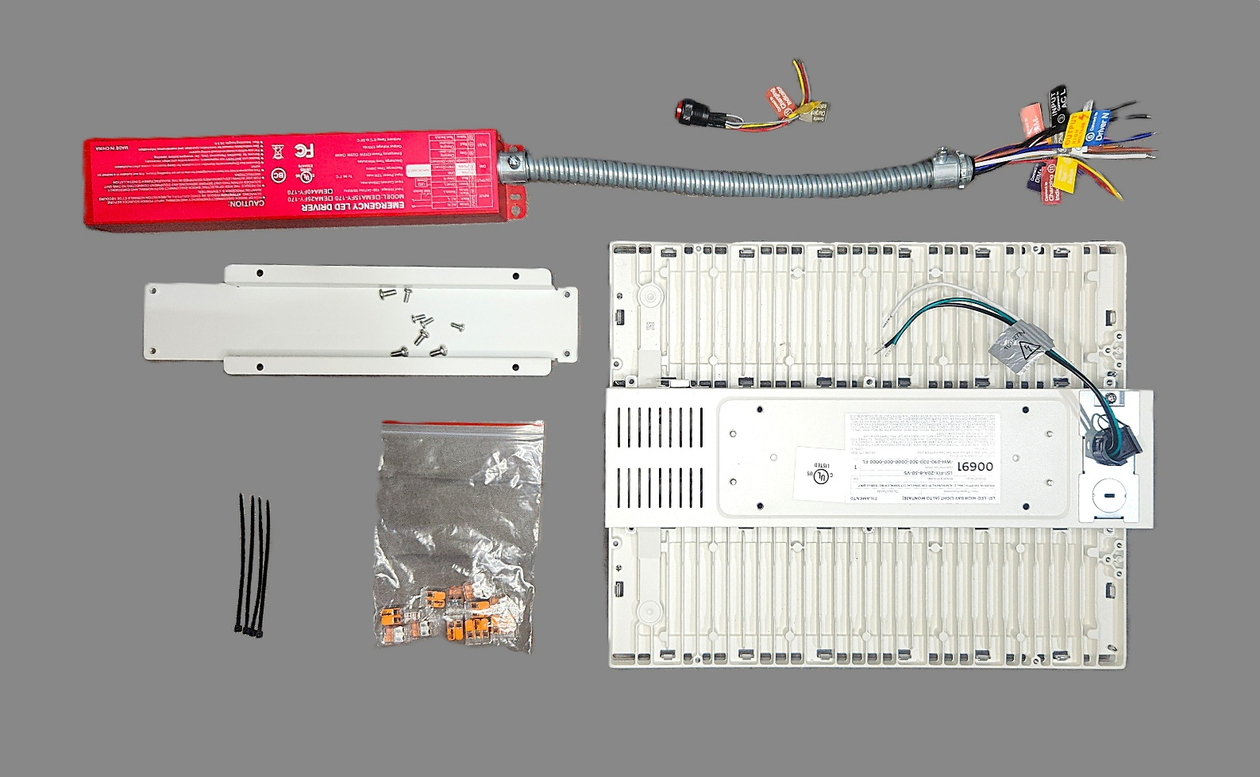

**Remove zip-ties**

### Remove the two “knockouts” on the end of the fixture:

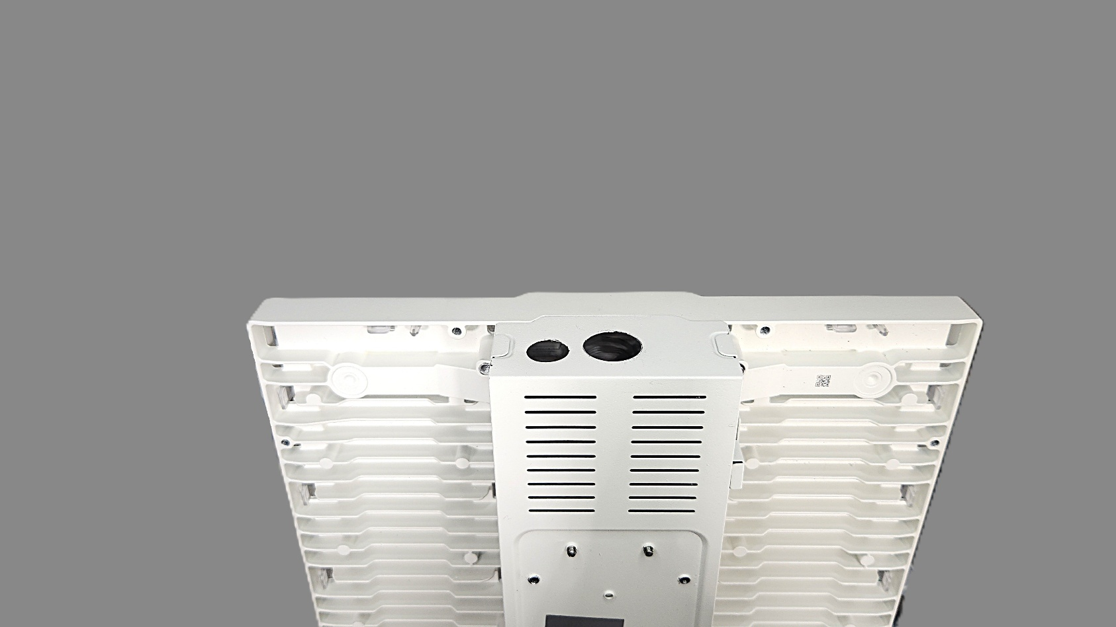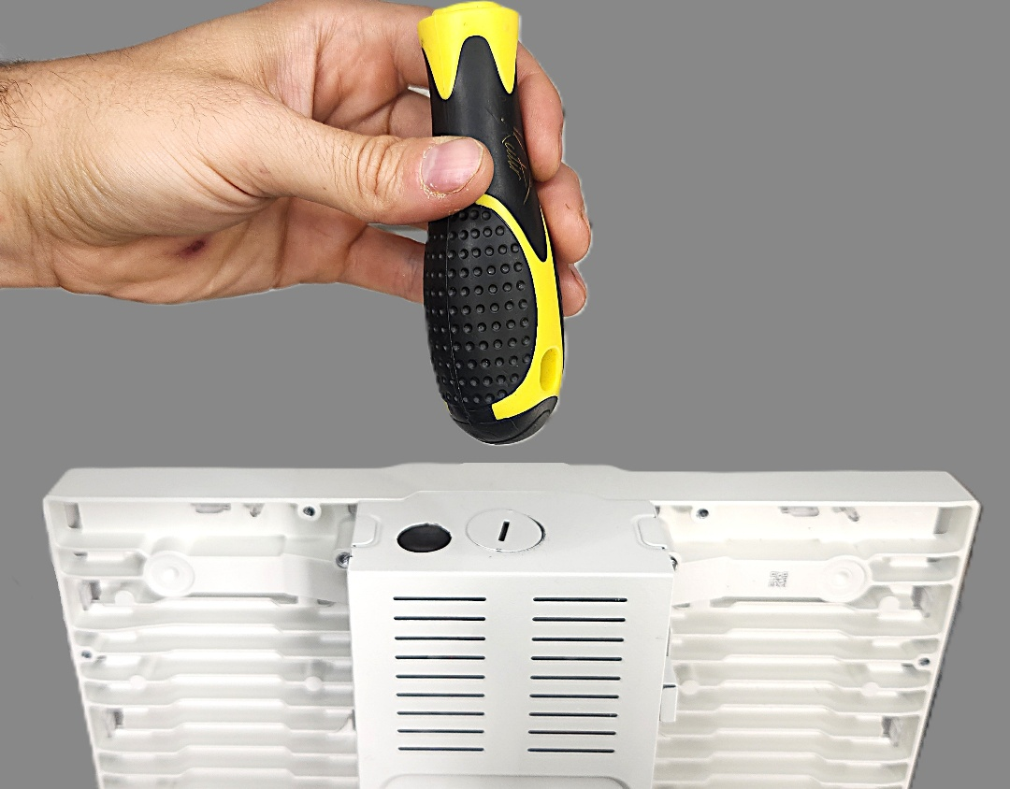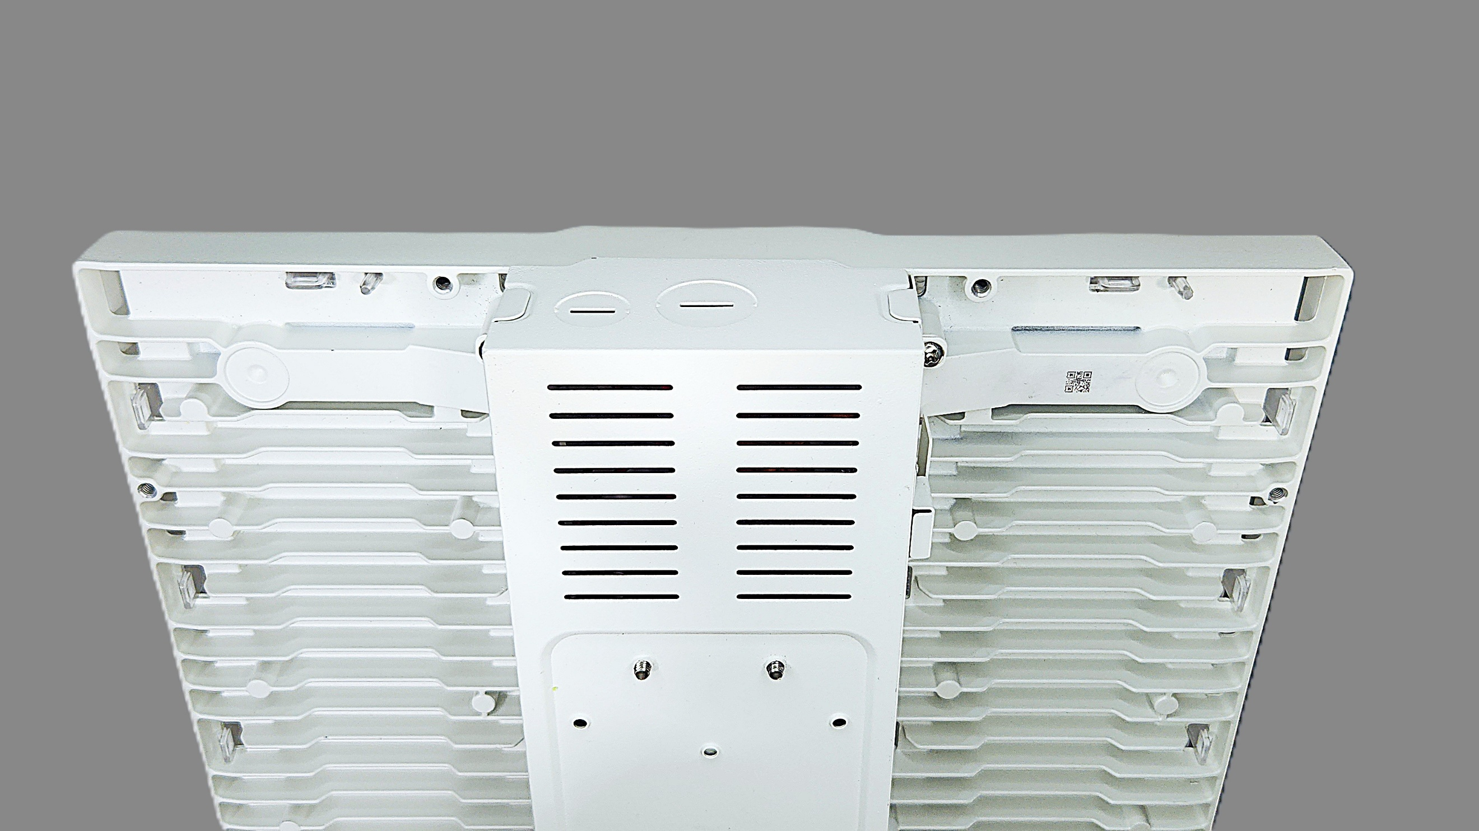

### Use the electric screwdriver to remove six screws securing the LED driver panel:



**x6**

**Remove**

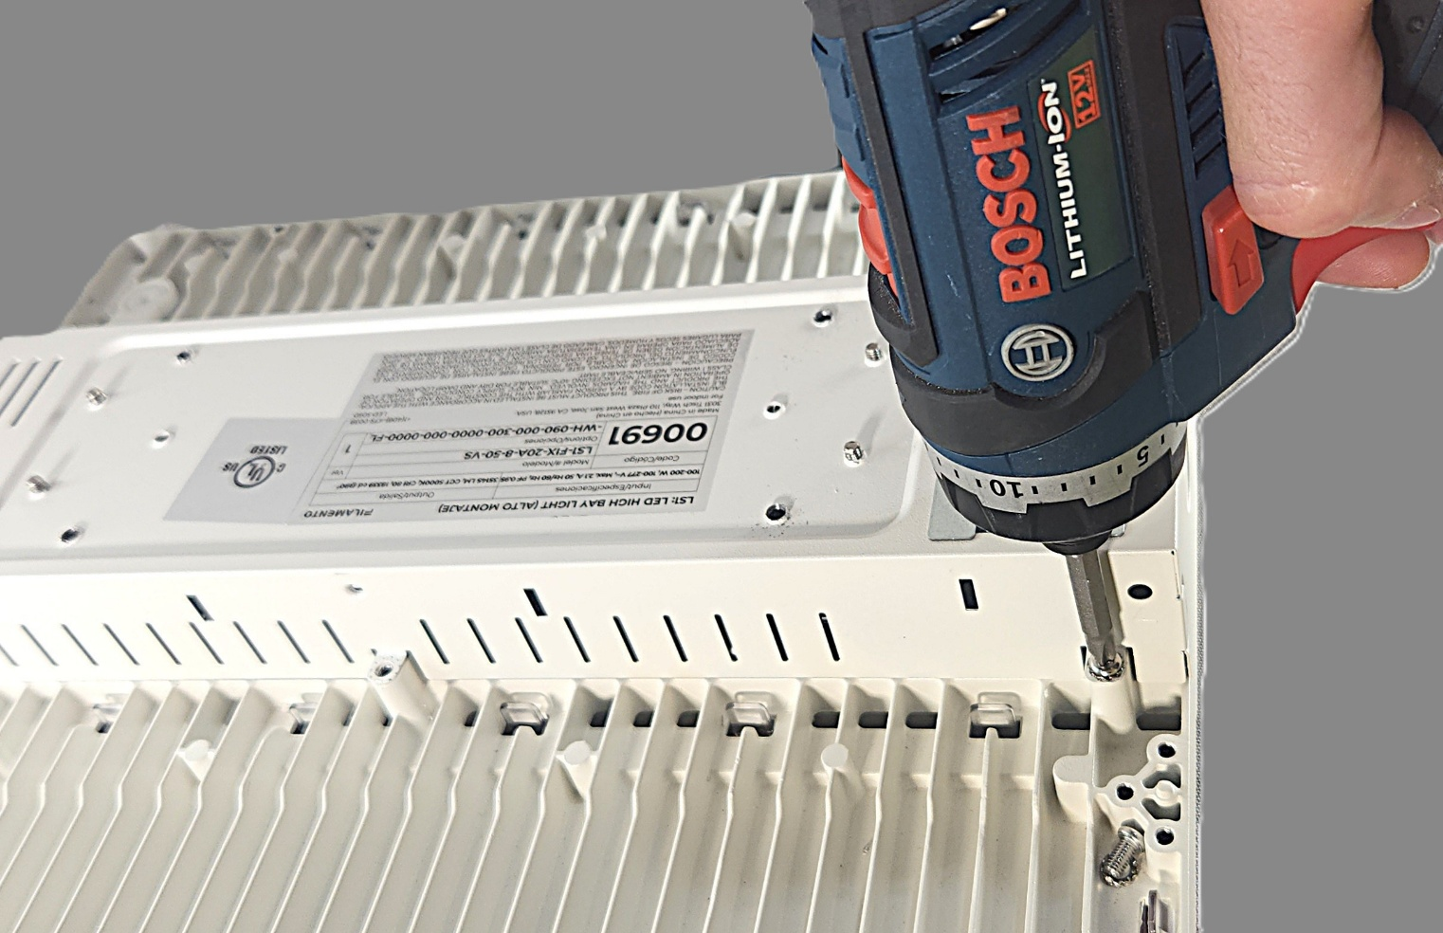

### Open the LED driver cover to expose the wiring:

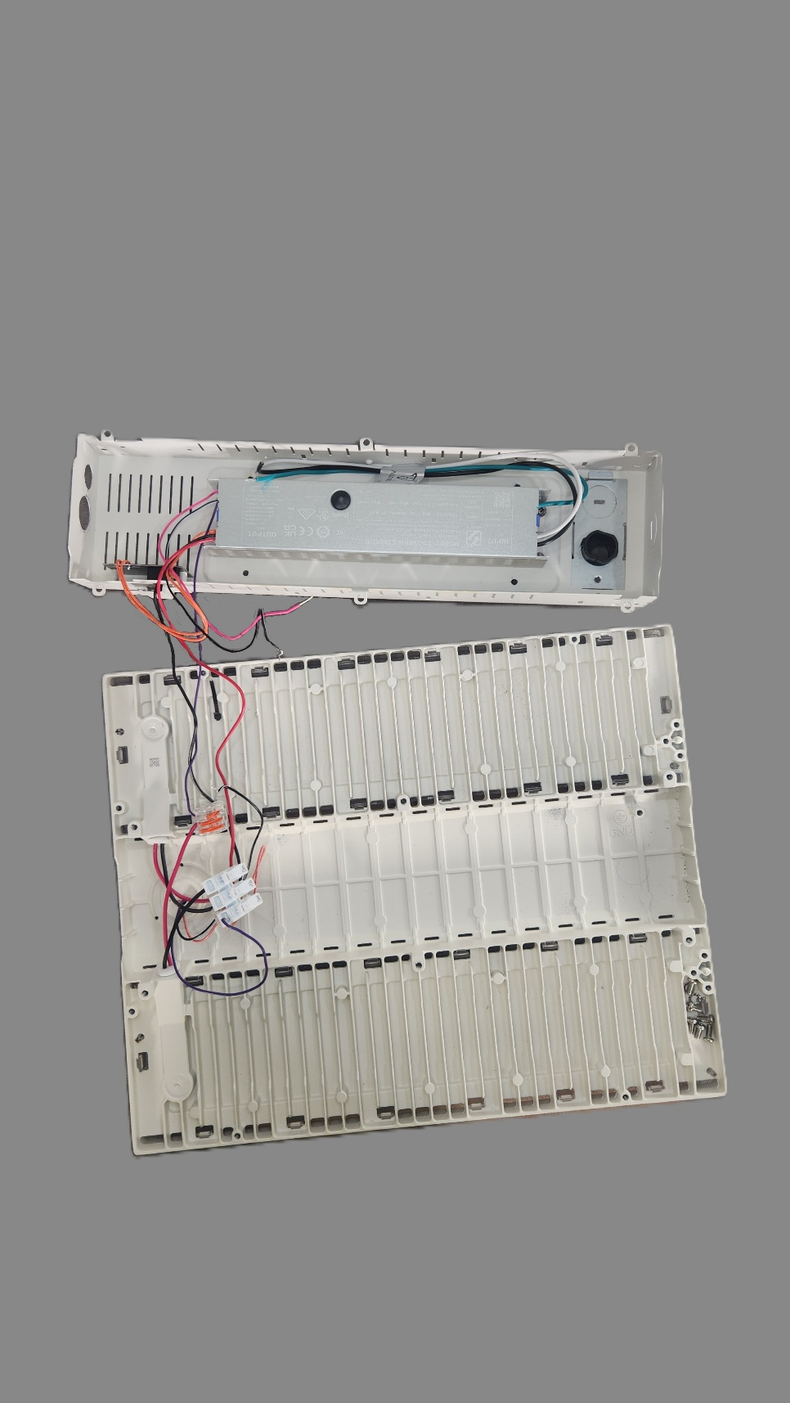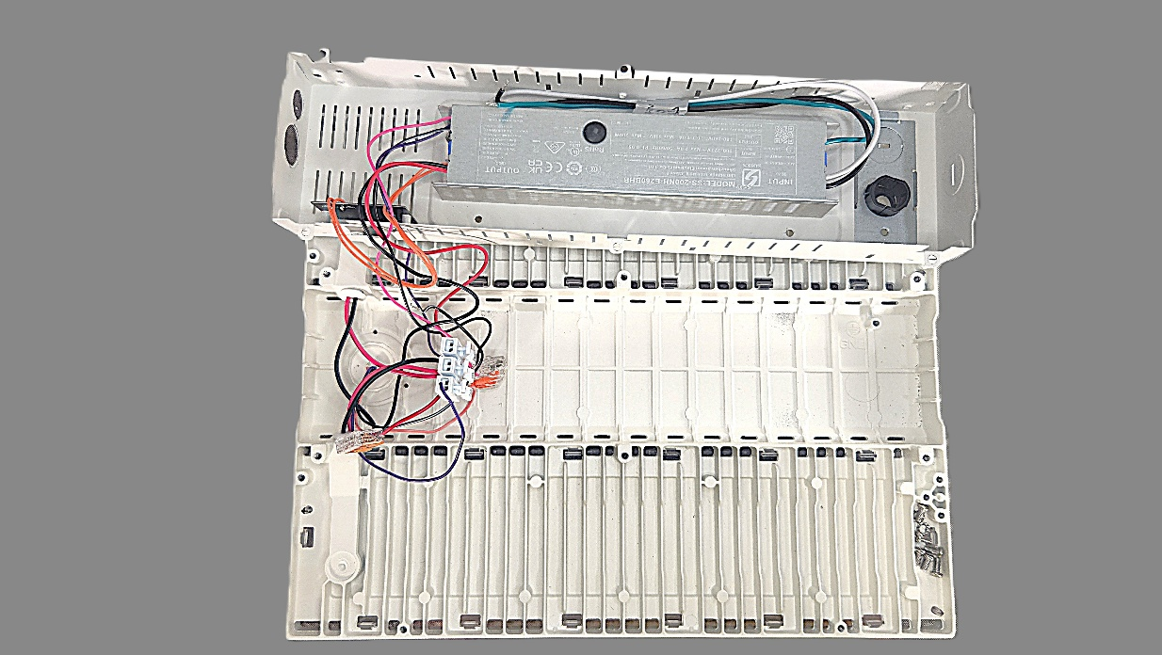

**Do not strain wires**

### Attach the button assembly to the LED driver cover:

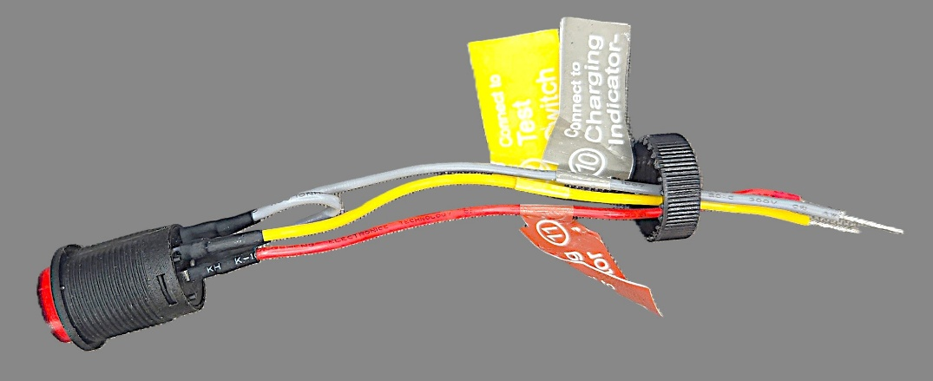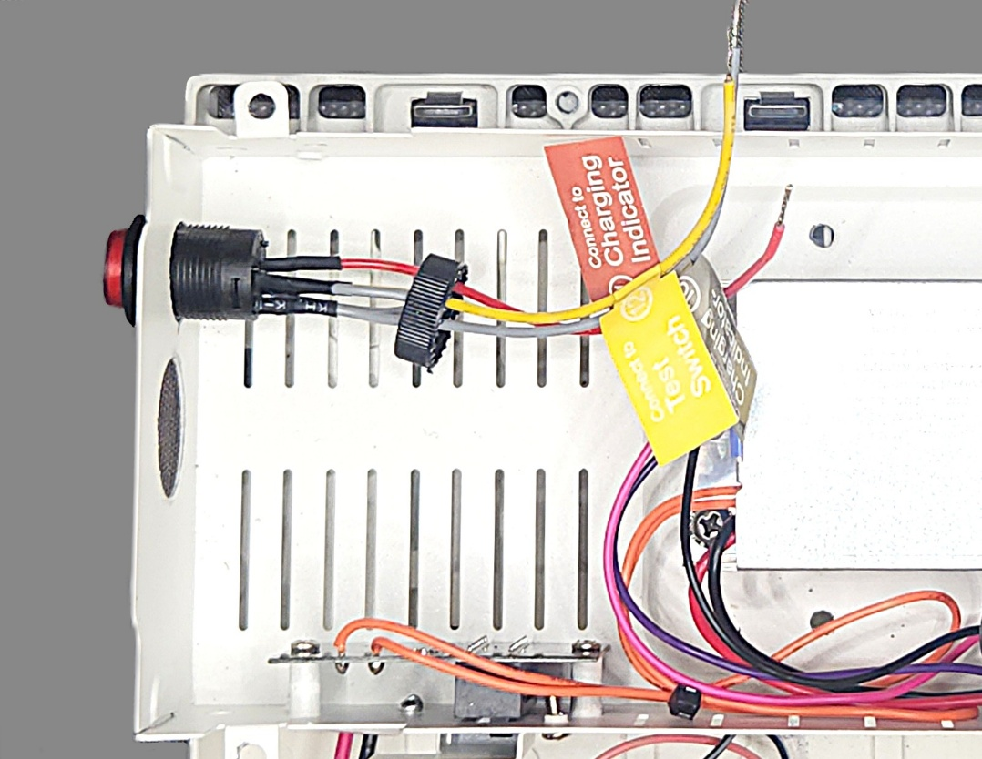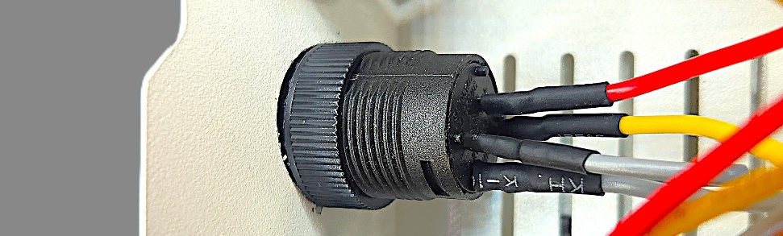

**Hand tighten only**

### Attach the EM battery wire harness to the Lx1 fixture with the lock ring:



**Not tight Screw must face DOWN Not centered**

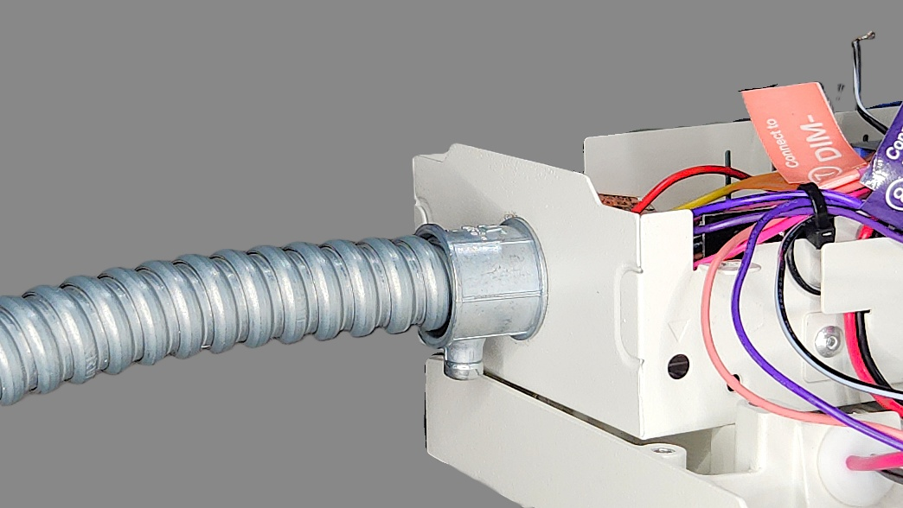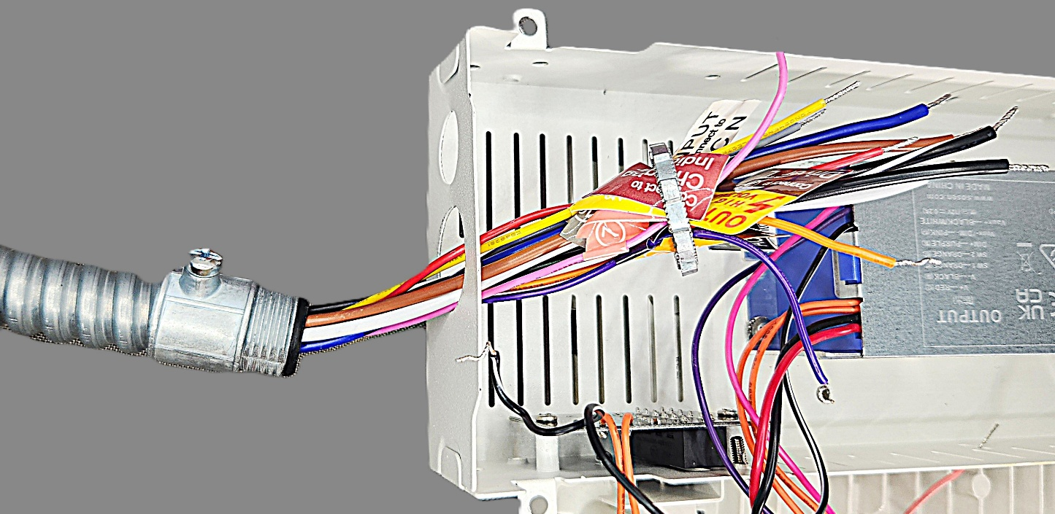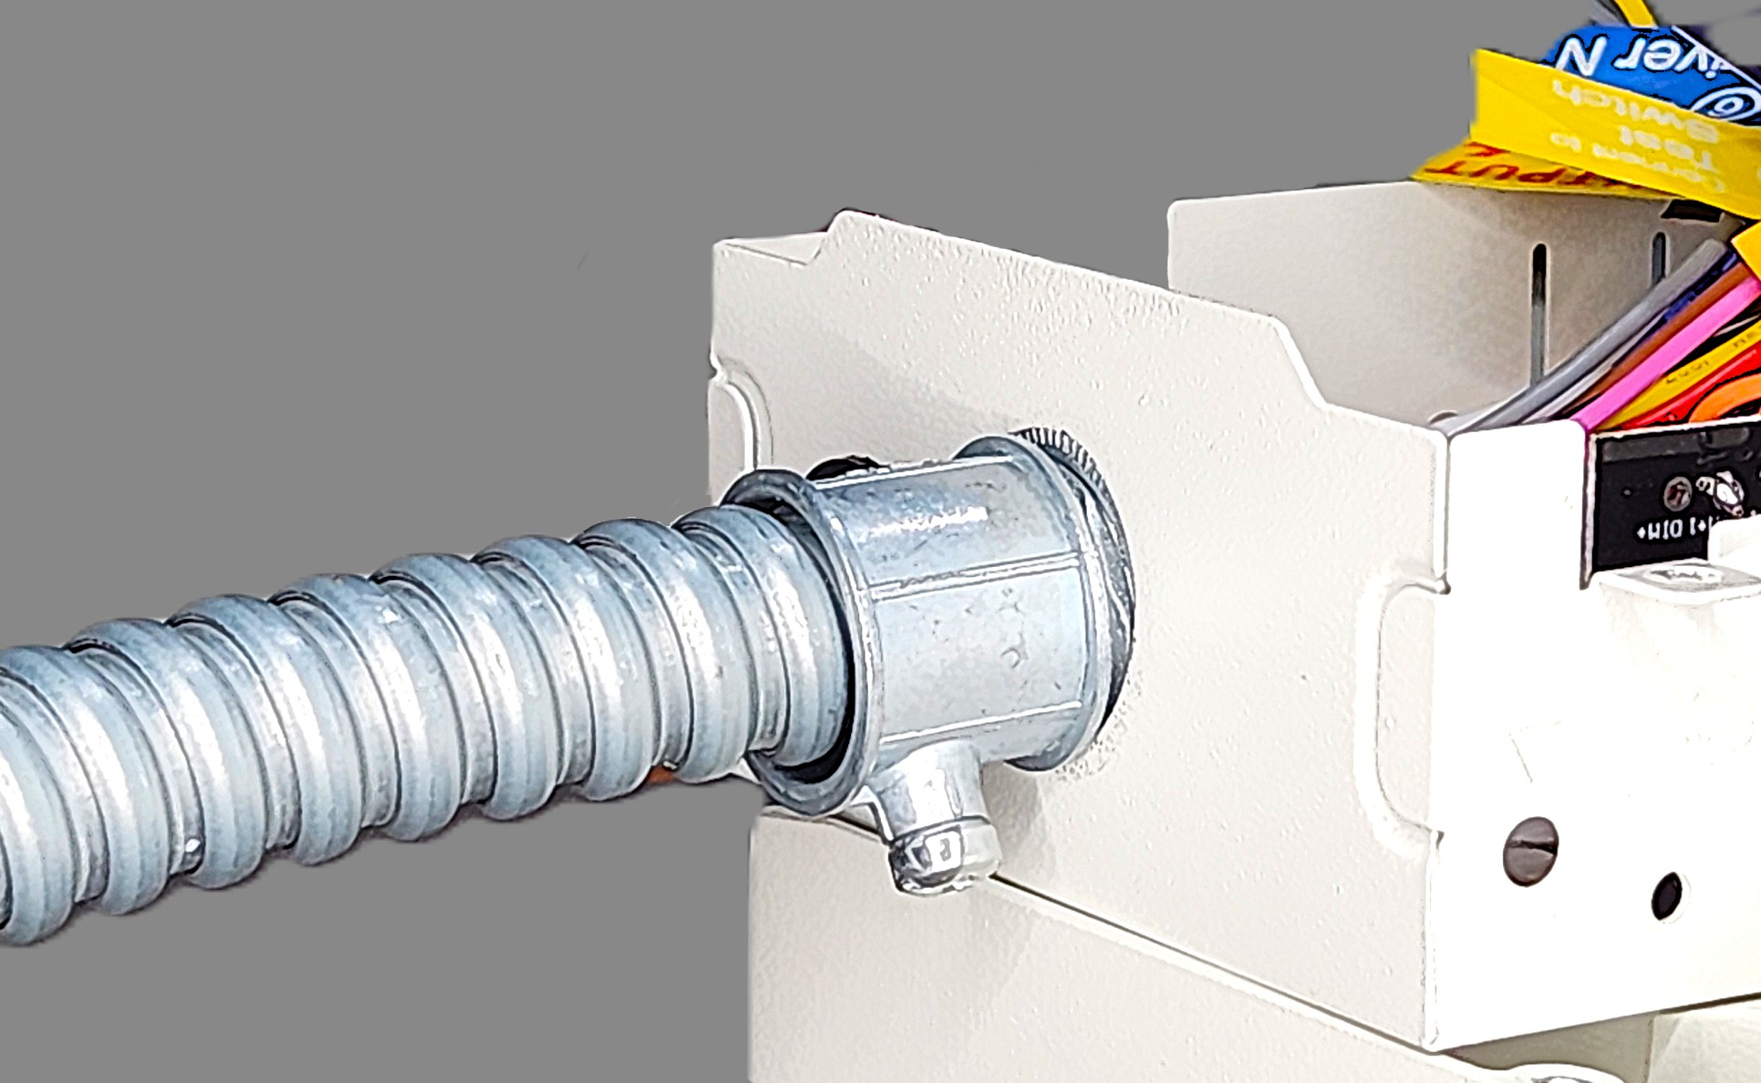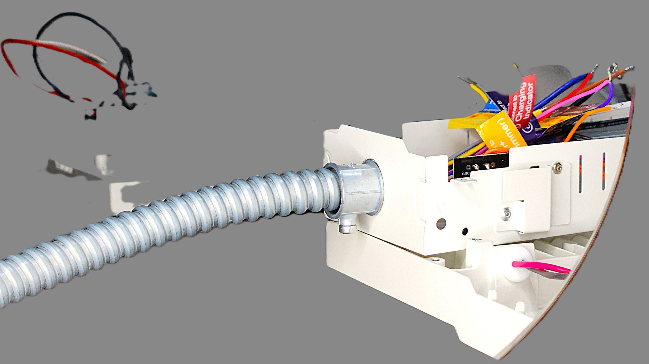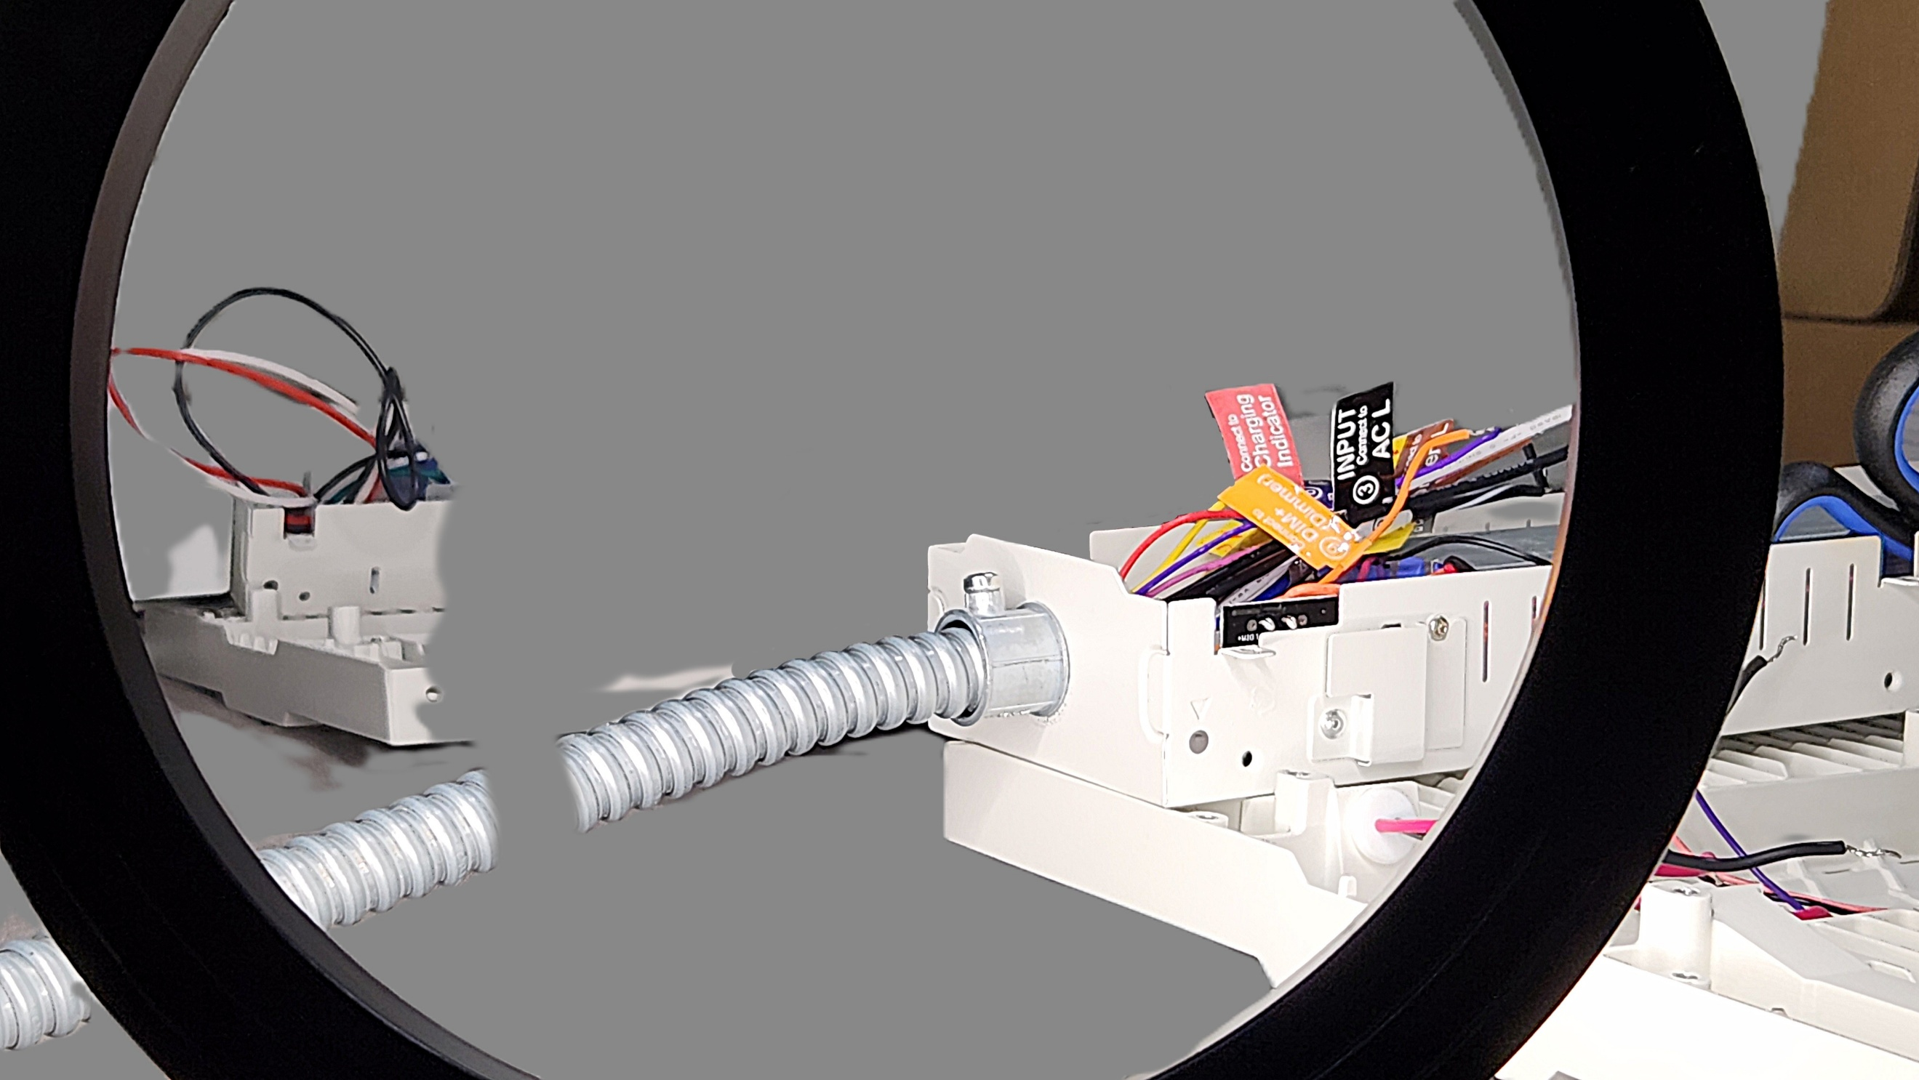

### Reposition the driver wires and attach 2-position Wago clips:

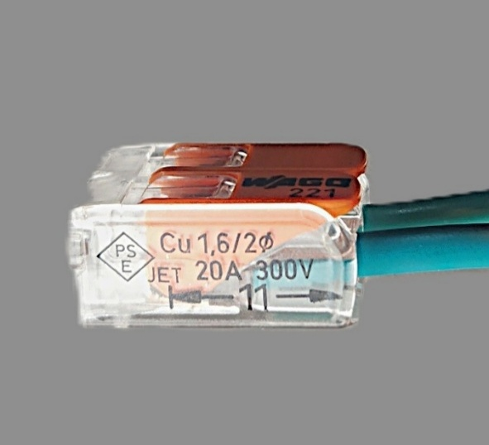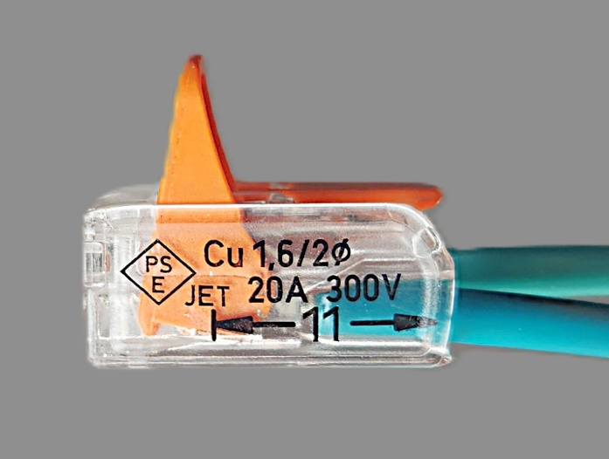

**Wire strands are inserted to back of the clip**

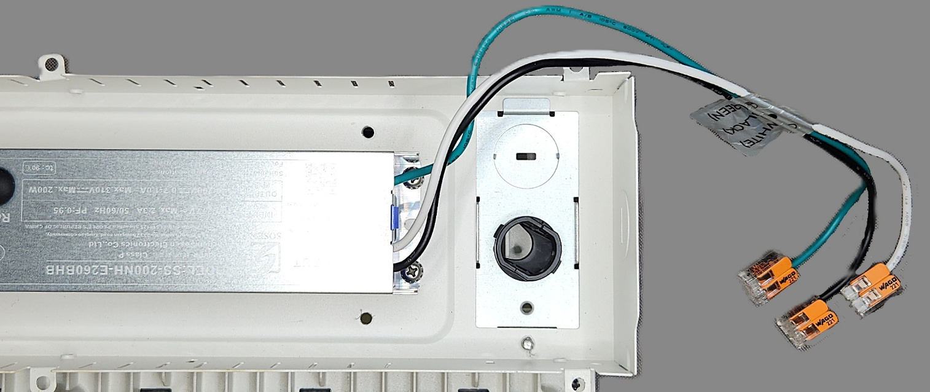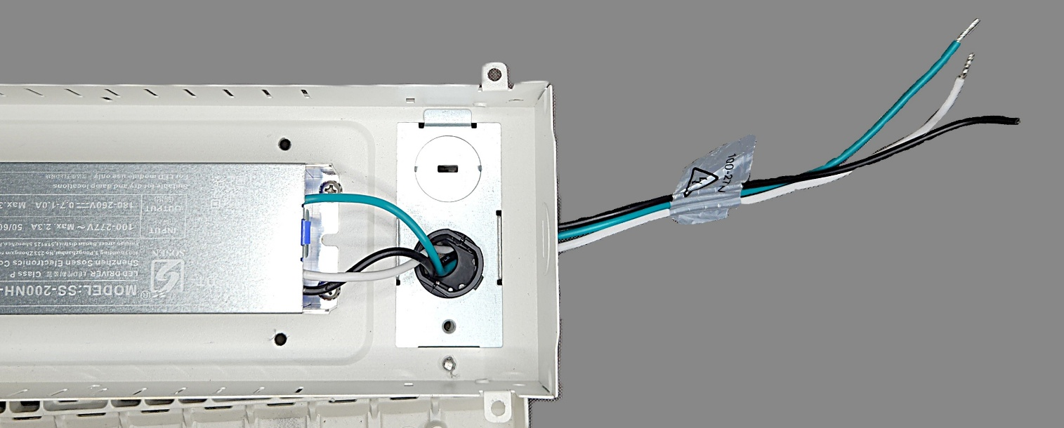

**X3**

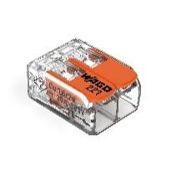

### Wire the EM battery, test button, LED driver, and 3-pin receptacle with 2-position and 3-position lever connectors:



**Do not use**

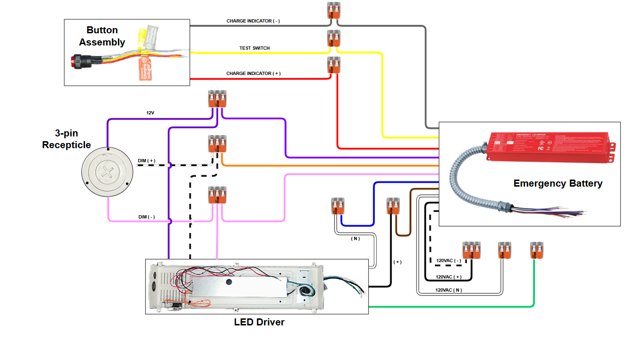

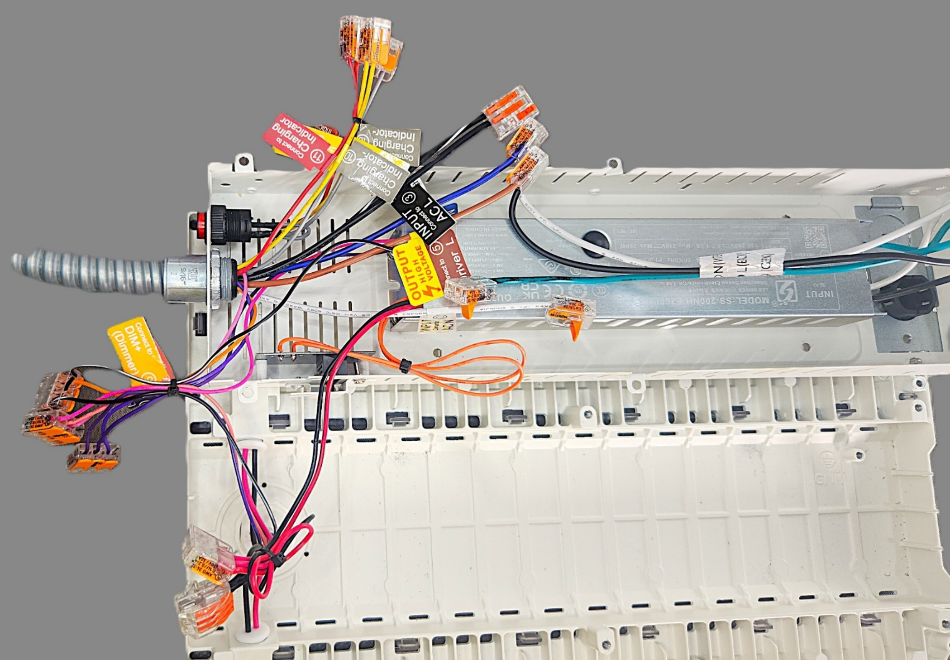

**X4**



**Loop excess wiring in place**

## Quality Control Steps

*Remainder of procedures removed from writing sample*

# REFERENCED & SUPPORTING RESOURCES

|  |  |
| --- | --- |
| **Document Number** | **Document Title** |
| [PRT-RWK-1024](https://frankshum.sharepoint.com/:x:/s/SOP/EZLLjNUZJlBGry5JKiEL1FMBCrCTyzpT8nkq6xWjPfjX4g?e=0IsV4N) | EM Battery Rework Part Numbers |
|  |  |
|  |  |

# GLOSSARY

|  |  |
| --- | --- |
| **Acronym or Term** | **Definition or Meaning** |
| AWG | American Wire Gauge – a standard measure of the thickness of wire |
| BOM | Bill of materials |
| EHS | Environmental Health and Safety – refers to the aspects of a workplace environment that must be assessed for health and safety hazards |
| EM battery | Emergency Battery |
| Rework | The process by which base models of products are physically modified to meet predetermined specifications including but not limited to power |
| Voltage | A measurement of electrical potential (v) |
| Wattage | The rate of energy transfer; equivalent to one joule per second (w) |

# ROLES & RESPONSIBILITIES

|  |  |
| --- | --- |
| **Role** | **Responsibilities** |
| Process Owner | Keeps staff apprised of changes to process, safety, and equipment and ensures that changes are initiated on associated documentation. |
| Technician | Performs the work described in this document. |
| Reviewer/Approver | Reviews and approves major revisions. |
| Author | Authors/edits technical documentation |
| Supervisor | Designated senior employee who oversees Technician |

# CAUTIONS, EHS, AND SAFETY PRACTICES

## Danger: electrical shock and burn hazard

### This procedure involves working with live electrical components and AC mains power. Improper handling and improper connection of wiring may result in:

1. Severe electrocution
2. Arc flash and electrical burns
3. Equipment damage

### Fire and burn risk: DO NOT leave the Lx1 turned on for more than five minutes while it is resting on a table surface. Accumulated heat damages the unit and may start fires.

## Required safety precautions:

1. De-energization: ALL electrical components MUST be completely disconnected and powered off before making or breaking any connections. Never connect or disconnect Wago connectors or fixture wires while energized.
2. Qualified Personnel Only: This procedure must only be performed by personnel trained in electrical safety and authorized to work with energized equipment.
3. Connection Verification: Always verify proper polarity (live, neutral, ground) before energizing. Reversed connections can create shock hazards.
4. Emergency Procedures: Know the location of first aid equipment. In case of electrical shock, do not touch the victim until power is disconnected.

# Revision History

|  |  |  |  |
| --- | --- | --- | --- |
| **Revision** | **Effective Date** | **Author** | **Description** |
| 1.0 | Oct. 2025 |  |  |
| 2.0 | Not released |  |  |
|  |  |  |  |
|  |  |  |  |
|  |  |  |  |
|  |  |  |  |
|  |  |  |  |
|  |  |  |  |

# Current Revision Approvals

|  |  |  |  |
| --- | --- | --- | --- |
| **Role** | **Name / Title** | **Signature Date** | **Electronic Signature** |
|  |  |  |  |
|  |  |  |  |
|  |  |  |  |
|  |  |  |  |